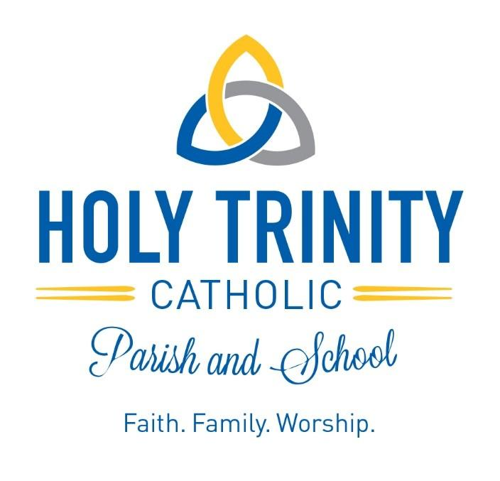

HOLY TRINITY SCHOOL
TUITION CONTRACT
2024-2025

As the Parent(s)/Guardian(s) of __________________________________________________ we/I ask that our child(ren) be enrolled at Holy Trinity Catholic School for the 2024-2025 school year. We/I accept total responsibility for payment of tuition and fees for our child(ren) as indicated below and per contract.

Family Name: _______________________________________________________________________

Name of person responsible for tuition and fees, if different:________________________________

Parish: _____________________________________________________________________________

TUITION RATES
3K-8th Grade
Number of  Children | Tuition | Actual Cost of Approximate Cost of  Education (2022-2023) Education (2023-2024)
1 Child | $3,396.00 | $9,309 (cost per student) $9,900
2 Children | $6,032.00 | $18,618 (cost of 2 students) $19,800
3 Children | $8,010.00 | $27,927 (cost of 3 students) $29,700
4 or More Children | $8,010.00 | $37,236 (cost of 4 students) $39,600
Balance is subsidized by
Holy Trinity Parish Tithing
3K/4K (Mornings – 7:30-11:30) $2,264.00
3K/4K (Full Day – 7:30-2:30) $3,396.00
*If you choose mornings and would occasionally like to have your child stay for a full day, it will cost $20.00 per day. Please let the office know the week beforehand if this will happen.

FEES
Non-refundable Instructional Fee on or before February 23, 2024: $100 for the first child and $50 for each additional sibling.
Non-refundable Instructional Fee after February 23, 2024: $200 for the first child and $100 for each additional sibling.

PAYMENT OPTIONS: (Please check one)
_____ Pay in full on or before September 1, 2024
_____ Ten monthly payments (August – May) due on the 1st of the month
_____ Twelve monthly payments (July-June) due on the 1st of the month
Tuition Incentive:
- Family Referral: Refer a family that registers and enrolls at HTS for the 2024-2025 school year and receive $500 off your tuition bill! Discount is for one year, one per family. Family you referred: ___________________________________________________
- SCRIP Program: The financial profit earned through the purchase of SCRIP during the fiscal year is divided into a 50/50 split: 50% of the profit goes to the school and the other 50% in profit is deducted from the family’s tuition the following school year. Eighth grade students, with no returning siblings to Holy Trinity School, will have the balance of their
SCRIP account applied to their tuition in April of their graduating year.
TUITION ASSISTANCE 3K-8: Follow policy and procedures outlined in the Tuition Assistance Packet.
Deadline for application: May 1, 2024.
SCHOLARSHIP APPLICATION: Follow the scholarship application procedures. Deadline for application: April 18,2024
TERMS OF TUITION CONTRACT
*Tuition may be paid in full or due each month based upon the contract plan you select.
*Tuition for students enrolling after the start of the school year will be pro-rated and based upon the calendar month in which the student is enrolled.
*I understand that all Tuition and fees MUST be current to be eligible for re-enrollment for the next calendar school year.
*I understand that initial enrollment is contingent upon successful completion of this Tuition Contract and applicable fees.
*I hereby acknowledge that as the parent or legal guardian of the child(ren) being registered, I am responsible to keep all information authorizations and emergency contact information pertaining to the child(ren) correct and current at all times.
*I understand that participation in Catholic education at Holy Trinity School is a commitment of Time and Talent in addition to that of Treasure. I agree to support the school with my gifts of Time, Talent, and Treasure by way of volunteer assistance and participating in school fundraising activities.
*I agree to follow the rules and policies established by the Archdiocese of Milwaukee and those stated in the HTS Family Handbook.
*I agree to live my faith to the best of my ability, to participate at Mass regularly and see to it that my child(ren) who are enrolled at Holy Trinity School do the same. I further agree to be involved in the life and mission of our local parish and to financially support my parish through regular tithing.

As parent/guardian, I/We agree the tuition amount is accurate and will pay this amount. I am aware that additional discounts may be applied at a later date due to tuition assistance, if I apply for and receive such assistance. I accept total responsibility for timely payment of tuition as indicated per this contract. I further understand that if my financial obligations to Holy Trinity School are not current, registration will not be accepted for the following year until the tuition payments become current or a payment plan is submitted for approval by the business manager.

Furthermore, I understand that tuition covers only about half of the total cost per student. Parishioners of Holy Trinity Parish and St. Michael Parish subsidize the HTS working budget and provide all the facilities the school utilizes, and staff members accept smaller salaries than their public school counterparts.

I, the undersigned, accept the financial obligations set forth above.

Parent Signatures ______________________________ _________________________________
(Father/Legal Guardian) (Mother/Legal Guardian)

Date _____________________________

All payments are to be made to Holy Trinity School. All financial information is strictly confidential.
Please return this entire form to the school office by February 23, 2024. If you would like to receive a copy for your records, please contact Mrs. Longden.

