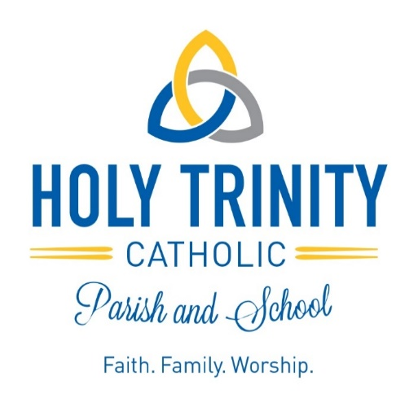

January, 2023

Dear Families,

Welcome to Holy Trinity Catholic School! We will begin to send you our weekly newsletters so you can see all that is happening at Holy Trinity. Included with this letter is a new student registration form. Please complete this form and return it to the school office.

If you are interested in volunteering or attending field trips in the future for Holy Trinity School, now is the time to consider doing the steps to volunteer. All volunteers are required to meet three requirements: attend a Safe Environment session, pass a criminal background check (no cost to you), and sign the Code of Ethical Standards. For more information on Safe Environment for the Archdiocese of Milwaukee go to http://www.archmil.org/Offices/Safe-Environment.htm

Raising children in the Catholic faith can be a very huge challenge with all the social influences that exist today. Having a school that supports the foundation you’ve begun at home is hard to find. Holy Trinity Catholic School continues a child’s faith formation. Holy Trinity can shape a child’s soul and mind. We hold the faith formation of our students at the heart of all we do, honoring and cherishing the faith traditions here, while looking to the future to grow our school’s Catholic culture.

The faculty and staff of Holy Trinity are committed to providing quality Catholic education in a nurturing learning environment. We have dedicated educators who are ready to challenge, inspire, and guide your child. By choosing Holy Trinity Catholic School you have become a part of a faith community and will provide your child with a faith-based educational opportunity that truly does provide an excellent start for your child’s future. As always, I welcome your questions, input, and support regarding your child’s education. I am committed to our mission to help your child develop his/her God-given potential to learn, to grow, and to make a difference in the world.

God Bless,

Mrs. Amanda Longden
Principal, Holy Trinity Catholic School

