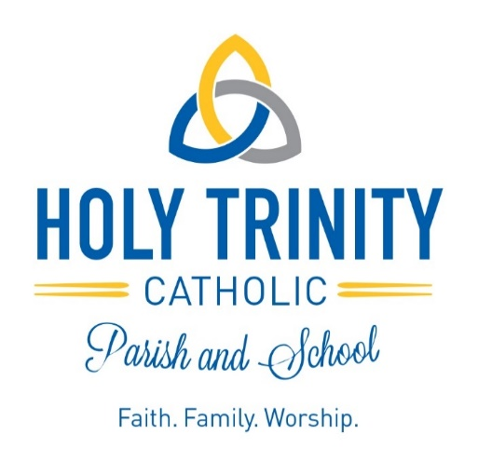

January, 2024

Dear Holy Trinity School Families,

We would like to take this opportunity to thank you for choosing Holy Trinity Catholic School for your child’s Catholic education. We know that one of the most important decisions you make as a parent/guardian is that of choosing the best education you can for your child. Thank you for allowing us to be a part of that important journey.

Our goal is to make a Holy Trinity education as affordable as possible; however, we cannot avoid a slight increase in tuition. Holy Trinity Finance Council has deemed it necessary to increase tuition by 3% for the next school year. Expenses increase significantly each year and our staff continues to be underpaid. It cost over $9,300 to educate a child this past year and our parish has been gracious to subsidize the portion not covered by tuition and fundraising. It is important to work on decreasing the amount of the parish subsidy to align with Archdiocesan expectations.

Social Fest remains successful and parishioner tithing has been very generous. This favorable precedent permits us to only increase tuition by 3%. The success of future fundraising efforts is necessary to keep annual increases low in future years.

Your registration will be accepted once we have the instructional fee(s) per child. The 2024-2025 school year registration packet consists of the following:

- Family Registration Form – Please fill out a paper copy.
- Tuition Contract – (Instructional Fee - $100 for the first child and $50 for each additional sibling if paid before February 23, 2024)

In order to be enrolled, you must return the family registration form, and tuition contract together along with the instructional fee payment. It is important to return the items in a timely manner, as we do have a large number of students in our 3K-5K programs and will create a waiting list if need be.

If you have any questions, please contact Mrs. Longden at principal@htschool.net or (262)626-2603 ext. 101. Once again, thank you for choosing Holy Trinity Catholic School for your child’s Catholic education!

Blessings,

Mrs. Amanda Longden, Principal Father Patrick Magnor, Pastor

